- Install web Man Mod
- Start Game
- Use a browser to enter the ip address of the console.
- In the PS3MAPI tab find the Processes Commands section and enter the desired memory Address.
- Press Get.
- Scroll down to the Value section and change the Desired byte.
  - For the values, check on RPCS3 in the pages related to the game you want to unlock. A few are listed below.
- Press Set.
  - The screen will flash and the change should take effect immediately.
- We can create per title ID scripts via webMAN to apply them at boot

The Last of Us (v1.11)
- Address 1571A6F
- change the byte 02 (30fps) to 01 (60fps) or 00 (unlocked)
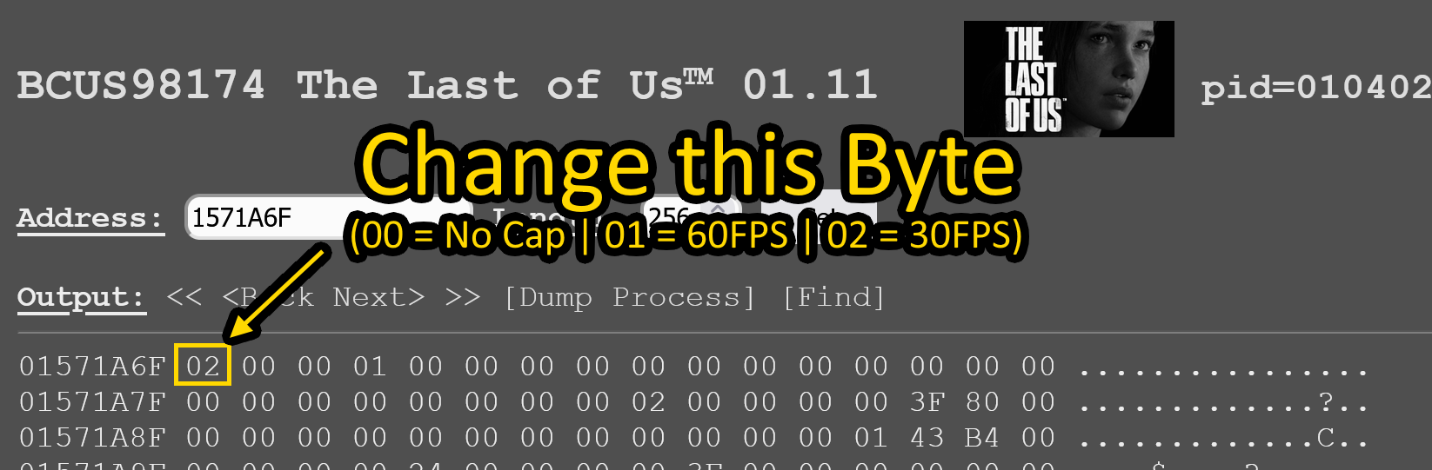

Grand Theft Auto 4 v1.00 & 1.08 (BLUS30127 & BLUS03702)
- Address: 00f18830
- Value: 08 to 00 (uncapped)
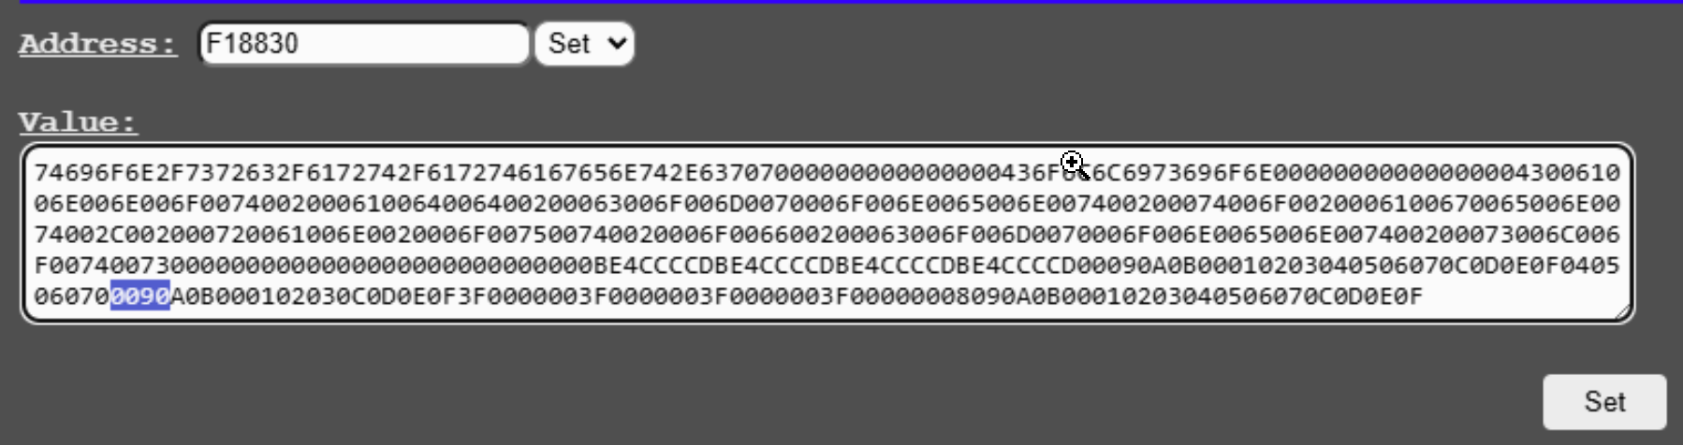

Uncharted 2 (v1.09)
- Address E9C1FB
- change the byte 02 (30fps) to 01 (60fps) or 00 (unlocked)

Final Fantasy XIII.
- Address 8d2e94
- value is 38800001.
- The game can reach and maintain 60fps in many moments, but it will lock at 30 in the open area at chapter 11. In combat the game will try to reach 60 depending on what's happening on screen.

The Elter Scrolls: Skyrim - Legendary Edition
- Address 8edb64
- Values to change is F865 to F805. (30fps 60FPS)

Skate 3 v1.05 (BLUS30464)
- Address 94713A
- Value to change is 06 to 00 for 60fps

Fallout 3 1.61 (BLUS30185)
- Address: 702bac
- change from F864 to F804 for 60fps

Just Cause 2 1.02 (BLUS30400)
- Address: 35d3e4
- change 7803 to 7800 for 60fps

Silent Hill Homecoming BLUS30169
- Addrress: 5a36c
- change from 57E0 to 3800 in game only, menu will crash

